Research / Business Grant

Funding Proposal

*Executive Summary*

Self-Healing Concrete: The Solution to Deterioration

Nguyen Xuan Binh

binh.nguyen@aalto.fi

Nuance Bricks OY

Virtually all constructions, ranging from streets, buildings, and bridges, are built with highly durable materials such as superalloy and non-oxidized materials. Among those materials, concrete is the most important material in constructions. However, due to reasons such as weather, human use or damage by rodents, small cracks will be formed into a matrix within the concrete, allowing air and water to contact with the frames, thus eroding them. The idea of self-healing concrete arises from this problem. At Nuance Bricks, the concrete able to refill its cracks is being developed by employing two different processes: chemical or bacterial encapsulation.

The first approach is chemical encapsulation. At the production stage, microcapsules containing healing chemicals are manufactured and subsequently mixed uniformly within the concrete. When cracks occur, the microcapsules between the cracks will break, releasing the chemicals and filling the cracks. [1] This method is highly versatile and pervasive over all cracks, both outside and inside the concrete. Nevertheless, this method lasts a limited time, because the chemicals inside the microcapsules will be depleted as they refill many cracks later.

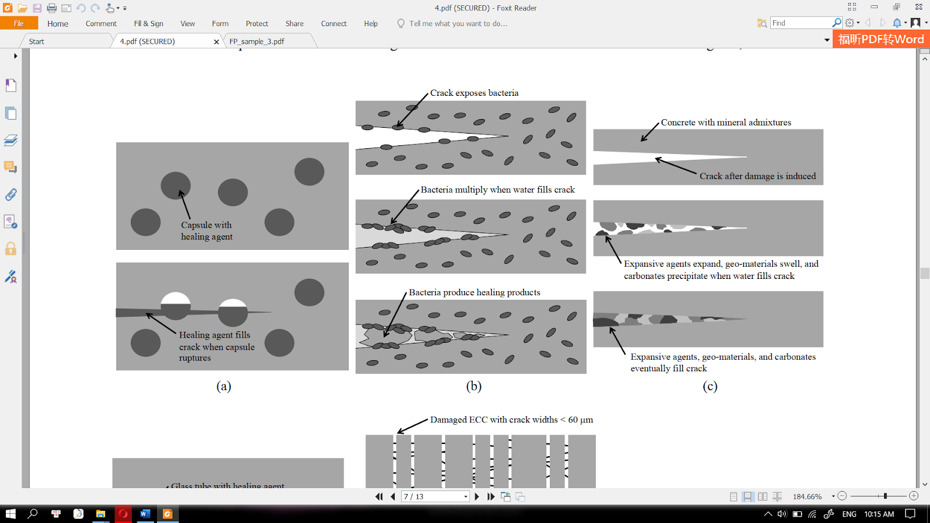

The second approach is bacterial encapsulation. This approach is nearly identical to the first method in utilizing capsules. First, bacteria of the Bacillus genus are cultivated in tiny pores, which are mixed within the concrete. Like chemicals of the first method, organic compounds are added inside these tiny pores for the Bacillus bacteria to feed on. As the bacteria thrive, they release calcium carbonate (CaCO3) due to their metabolism in high calcium environments [1]. When cracks occur, the water or vapor will allow the bacteria to multiply, produce calcium carbonate, and refill the cracks. With this method, the cracks can be refilled indefinitely as bacteria multiply. Unfortunately, this method only works underwater or a considerably humid environment.



Self-healing concrete will become a breakthrough to achieve sustainable infrastructure in many suburban areas in Finland. There are innumerable benefits, such as preventing unexpected collapses of buildings and significantly lowering the cost of repairs and maintenance. More importantly, this technology will curb the rate of deterioration, which helps buildings last as long as 200 years [2]. Many generations can use the same infrastructure without replacing the concrete. There are further applications of these technologies as well. For example, bacterial encapsulation can be utilized to filter pollutants from water streams, harden the sand and sustain the limestone architectures [3].

Self-healing concrete is currently developed at Nuance Bricks and requires a fund of 10000 € for feasibility testing. Nuance Bricks OY takes great concern in safety measures of construction projects while keeping maintenance costs as low as possible, fitting the sustainable lifestyle of the Finns. The long-term goal of this project is replacing normal concrete with self-healing one in future constructions nationwide around Finland. Considering the benefits that self-healing concrete can provide, this project will be a worthwhile investment.

References

1. Victo C.Li, E. H., (2012). Robust Self-Healing Concrete for Sustainable Infrastructure. Journal of Advanced Concrete Technology, Volume 10, pp. 207-218.

2. Eugene, M. (19th Dec 2018). The Pros And Cons Of Using Self-Healing Concrete For Your Next Concrete Project. Available at <http://riosremodeling.com/2018/12/19/the-pros-and-cons-of-using-self-healing-concrete-for-your-next-concrete-project/> (Accessed 29th Oct 2020)  
3. Henk M. Jonkers, A. T. G. M. O. C. E. S. (30th Dec 2008). Application of bacteria as self-healing agent for the development. Ecological Engineering, Volume 36, p. 230–235.